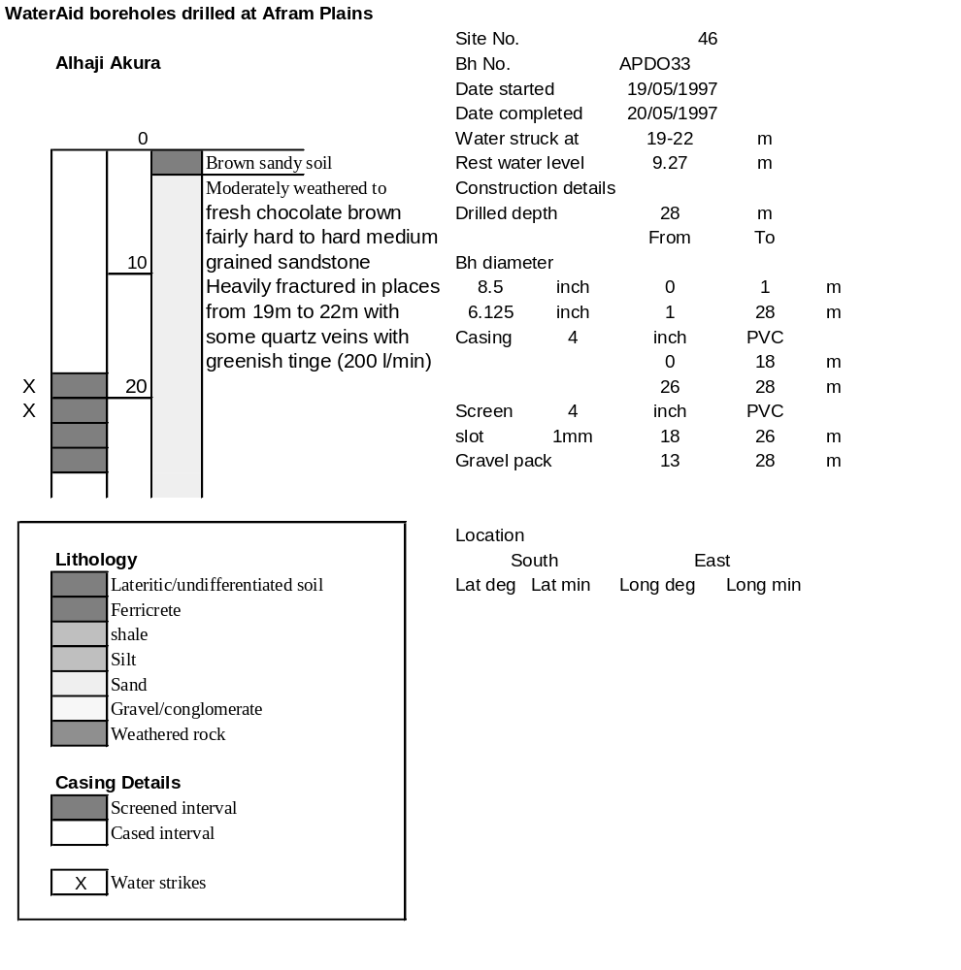

Ghana | Test pumping
Borehole No. |  | APDO 33
Hole No |  | 46
Village |  | Alhadji Akura II
Date |  | 08/06/1997
Point below GL |  | 1.08 | m
Pump depth |  | 21 | m
SWL |  | 9.27 | m
Start Time |  | 19:00
Drawdown test |  |  |  |  | Recovery Test
time | pwl (m) | Q l/min | dd | sc(q/s) | Time | wl (m) | t/t' | resdd
0.00 | 9.27 | 45.00 | 0.00 |  | 0.00 | 11.97 |  | 2.70
1.00 | 10.75 | 45.00 | 1.48 | 30.41 | 1.00 | 11.30 | 181.00 | 2.03
2.00 | 10.88 | 45.00 | 1.61 | 27.95 | 2.00 | 11.19 | 91.00 | 1.92
3.00 | 11.34 | 45.00 | 2.07 | 21.74 | 3.00 | 11.15 | 61.00 | 1.88
4.00 | 11.36 | 45.00 | 2.09 | 21.53 | 4.00 | 11.12 | 46.00 | 1.85
5.00 | 11.42 | 45.00 | 2.15 | 20.93 | 5.00 | 10.92 | 37.00 | 1.65
6.00 | 11.44 | 45.00 | 2.17 | 20.74 | 6.00 | 10.85 | 31.00 | 1.58
7.00 | 11.45 | 45.00 | 2.18 | 20.64 | 7.00 | 10.80 | 26.71 | 1.53
8.00 | 11.49 | 45.00 | 2.22 | 20.27 | 8.00 | 10.78 | 23.50 | 1.51
9.00 | 11.54 | 45.00 | 2.27 | 19.82 | 9.00 | 10.76 | 21.00 | 1.49
10.00 | 11.59 | 45.00 | 2.32 | 19.40 | 10.00 | 10.76 | 19.00 | 1.49
12.00 | 11.67 | 45.00 | 2.40 | 18.75 | 12.00 | 10.74 | 16.00 | 1.47
14.00 | 11.68 | 45.00 | 2.41 | 18.67 | 14.00 | 10.74 | 13.86 | 1.47
16.00 | 11.70 | 45.00 | 2.43 | 18.52 | 16.00 | 10.72 | 12.25 | 1.45
18.00 | 11.73 | 45.00 | 2.46 | 18.29 | 18.00 | 10.68 | 11.00 | 1.41
20.00 | 11.75 | 45.00 | 2.48 | 18.15 | 20.00 | 10.68 | 10.00 | 1.41
25.00 | 11.77 | 45.00 | 2.50 | 18.00 | 25.00 | 10.68 | 8.20 | 1.41
30.00 | 11.79 | 45.00 | 2.52 | 17.86 | 30.00 | 10.66 | 7.00 | 1.39
35.00 | 11.81 | 45.00 | 2.54 | 17.72 | 35.00 | 10.65 | 6.14 | 1.38
40.00 | 11.83 | 45.00 | 2.56 | 17.58 | 40.00 | 10.65 | 5.50 | 1.38
45.00 | 11.84 | 45.00 | 2.57 | 17.51 | 45.00 | 10.65 | 5.00 | 1.38
50.00 | 11.85 | 45.00 | 2.58 | 17.44 | 50.00 | 10.64 | 4.60 | 1.37
60.00 | 11.87 | 45.00 | 2.60 | 17.31 | 60.00 | 10.64 | 4.00 | 1.37
70.00 | 11.88 | 45.00 | 2.61 | 17.24 | 70.00 | 10.64 | 3.57 | 1.37
80.00 | 11.90 | 45.00 | 2.63 | 17.11 | 80.00 | 10.63 | 3.25 | 1.36
90.00 | 11.93 | 45.00 | 2.66 | 16.92 | 90.00 | 10.63 | 3.00 | 1.36
100.00 | 11.94 | 45.00 | 2.67 | 16.85 | 100.00 | 10.62 | 2.80 | 1.35
110.00 | 11.95 | 45.00 | 2.68 | 16.79 | 110.00 | 10.62 | 2.64 | 1.35
120.00 | 11.96 | 45.00 | 2.69 | 16.73 | 120.00 | 10.61 | 2.50 | 1.34
140.00 | 11.97 | 45.00 | 2.70 | 16.67
160.00 | 11.97 | 45.00 | 2.70 | 16.67
180.00 | 11.97 | 45.00 | 2.70 | 16.67

